**Submission Instructions:**

1. You can pick and submit any one of the below assignments.
2. Don't use any libraries or frameworks like React, Tailwind, Bootstrap, or jQuery.
3. Use only HTML, CSS and Javascript to complete the assignment.
4. Complete the assignment by 22-Dec-2023, 7:30 PM.
5. Publish/Deploy the task and provide us the published URL.
6. Make a 5-minute video explaining the features you added to the assignment. You can use Loom to record it or record directly with a phone camera and upload it to Google Drive. Share the video link with public access.
7. Submit the assignment & video using the below form: <https://forms.ccbp.in/Marmeto_Assignment_Submission_Form>

**Task 1:**

**Problem statement** : Create a product listing page

**Estimated Time**: 2 hours

**Requirements:**

* Make an API call to a given API to fetch a list of products.
* Create two layouts, one for list view another one for grid view make use of flex and grid to switch between view on click of button.
* On input of search bar variants matching to the search key should get highlighted
* Implement media queries to adjust the layout for different screen sizes.
* Utilize async/await for asynchronous operations while handling API.

**Steps to Complete the Task:**

**Set up the project:**

* Assess the given figma design to understand requirements clearly

**Fetch API data:**

* Use the Fetch API to make an API call to retrieve a list of product.
* Handle the asynchronous operation using async/await to fetch the data.
* API ENDPOINT(URL) : https://mocki.io/v1/0934df88-6bf7-41fd-9e59-4fb7b8758093

**Creating product card :**

* Create both product cards as per given design (Grid card and list card)
* That includes product title , image , badge , variants.

**Creating search bar**

* On input of the search bar anything that matches the key will be highlighted.
* Partial search should work.

**Creating Layout switch buttons**

* Layout switch buttons will change the layout between grid and list

**Test and refine:**

* Do a testing for search and layout switch button

**Finalize and submit:**

* Clean up the code, refactor if necessary, and optimize performance.

**Important links to resources:**

<https://www.figma.com/file/xG21MiqSOJcUDtJL085wSK/Untitled?type=design&node-id=0%3A1&mode=design&t=2hrQyQz1CrATZn75-1>

**APl** - <https://mocki.io/v1/0934df88-6bf7-41fd-9e59-4fb7b8758093>

(or)

**Task 2:**

**Instructions**

* When we click on the categories below, the card will be shown based on the category name.
* Product badge are dynamic and coming from api response
* Product card image should come from API response product image.
* We need to show Product title, Vendor name, Price, Compare at price, then calculated discount in % off.
* Add to cart button is just a dummy button.

**Resources**

* **Font family** - Inter - <https://fonts.google.com/specimen/Inter>

* **Product data API** : <https://cdn.shopify.com/s/files/1/0564/3685/0790/files/multiProduct.json>

**Output Reference Image**:

**Note**: This image is just for reference and also it is not cross.

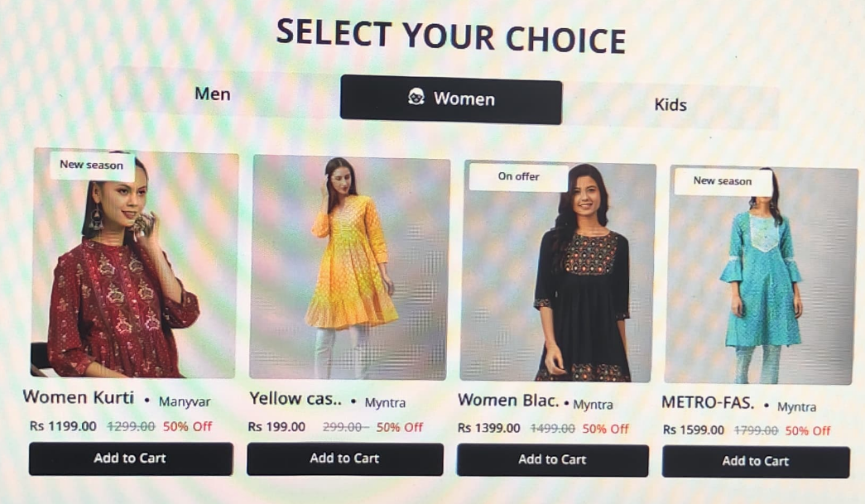

**Requirements**

* Create a tab switching layout.

* Create product card with following data

* Image
* Badge
* Product title
* Vendor
* Price
* Compare at price
* Calculate % off using JS.
* Create Add to cart button (Just a visual button)

**Tab Switching:**

* When the user clicks on the "Men", "Women", or "Kids" tab, show the respective product cards and hide the others.
* Implement a mechanism to toggle between the tabs, updating the displayed product cards accordingly.

**IMPORTANT POINTS**

* Use HTML, CSS, and JavaScript only to build the design
* Don't use any libraries or frameworks like React, Tailwind, Bootstrap, or jQuery.
* The webpage should be responsive across the devices.

**Mobile Screen**: Up to 767px

**Tablet Screen**: 768px to 1024px

**Desktop Screen**: Above 1025px